***Doubly Linked List***

A Doubly Linked List (DLL) contains an extra pointer, typically called the previous pointer, together with the next pointer and data which are there in the singly linked list.

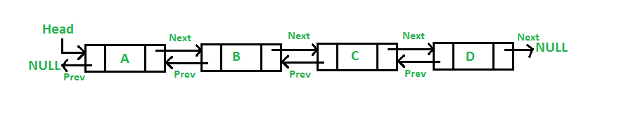

Following is a representation of a DLL node:

C++Java

// Class for Doubly Linked List

public class DLL {

// Head of list

Node head;

// Doubly Linked list Node

class Node {

int data;

Node prev;

Node next;

// Constructor to create a new node

// next and prev is by default initialized as null

Node(int d) { data = d; }

}

}